PortableOpenCPN_MAX Upgrade
Previously I published a download link to the PortableOpenCPN_MAX compilation which provided anchorages, charts and other items for the area spanning from the east coast of Africa to the west coast of the United States.
Some of the anchorages in Malaysia and Australia have links that open information in a browser.
For example, when opening the Properties of an anchorage (easiest way is to double click on it), the link will appear at the bottom.
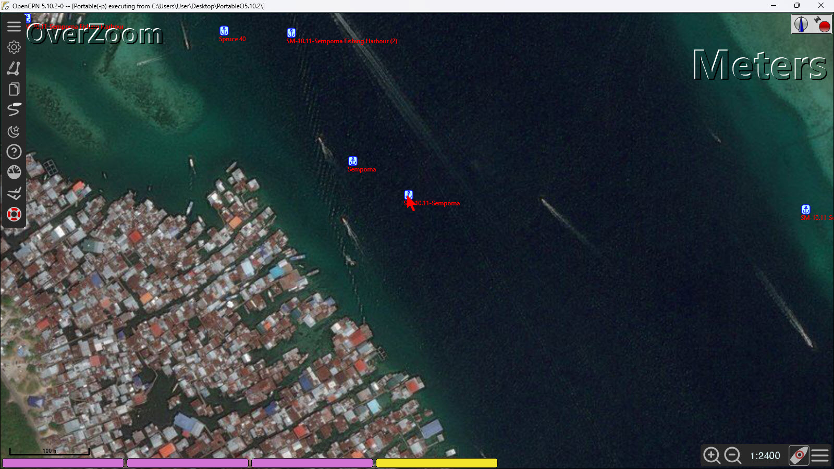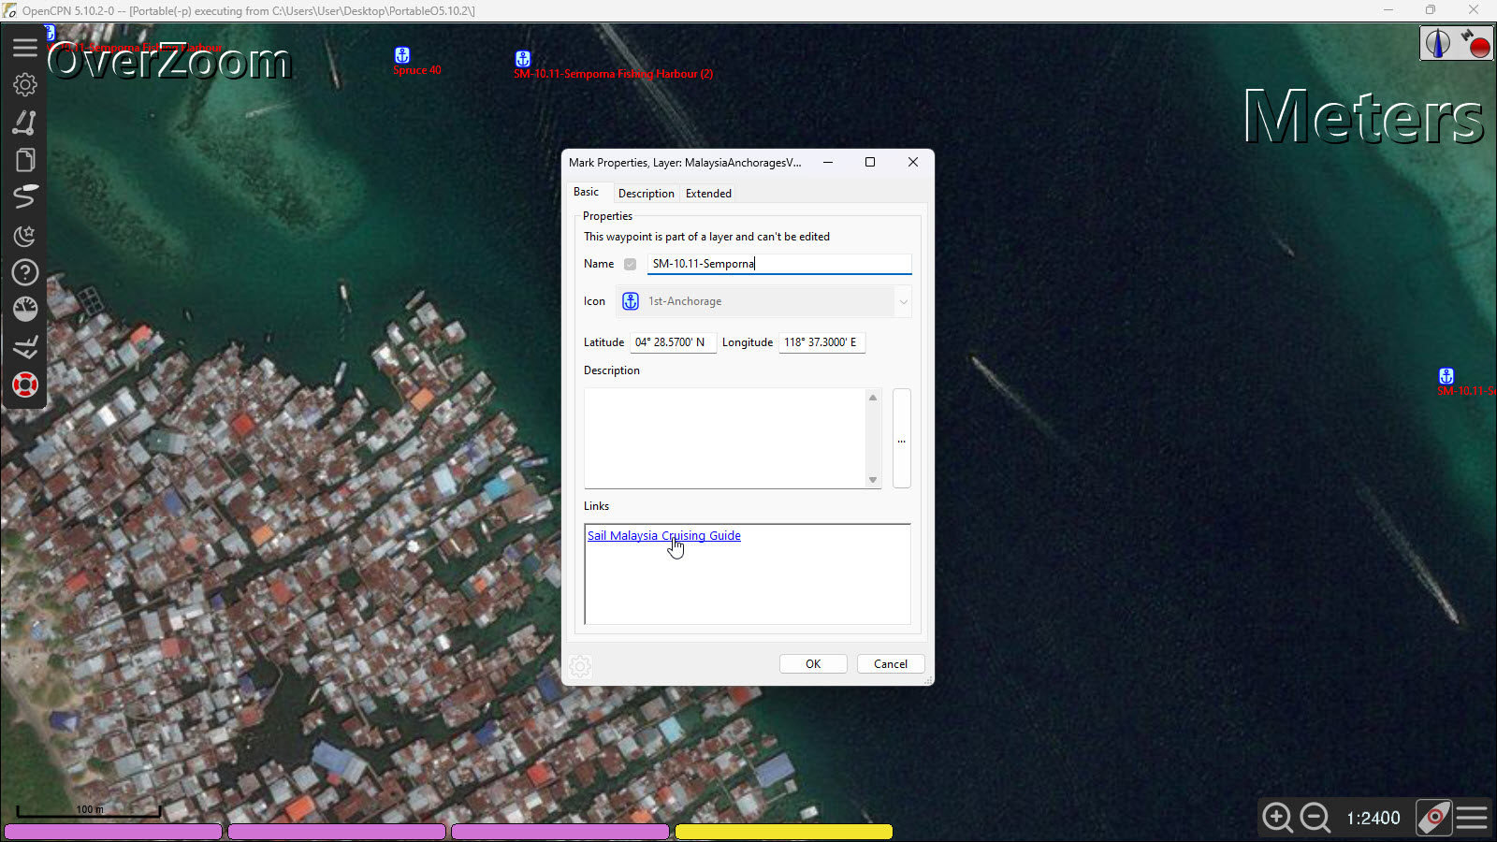
Clicking on this link opens information in your installed browser about this location.
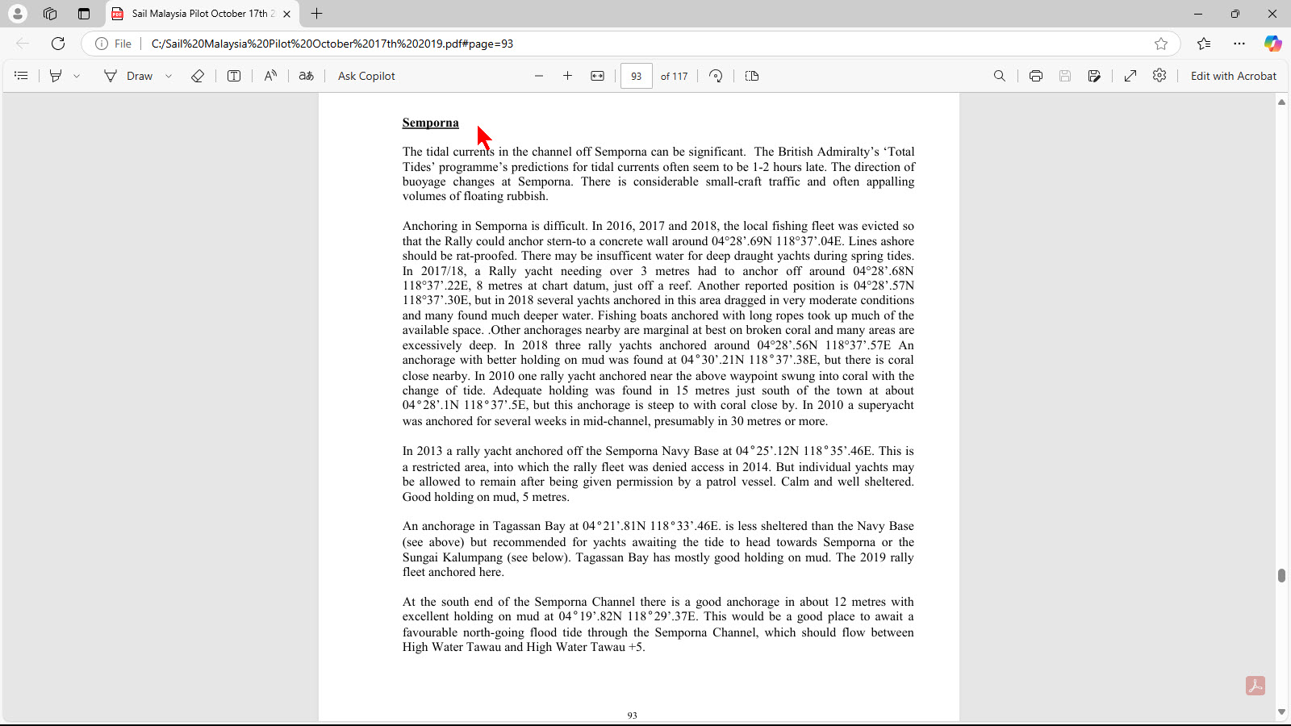

But for this to happen, these links require files to be put on the computer’s C: drive. The files to be added to the C: drive can be downloaded from this link.

Enjoy. Terry Sargent

