PORTS(Rev2) 22 Dec 2024
There were times while sailing when I needed assistance from shore in the way of workshops, onward transportation or medical assistance that could normally be found near seaports. For this purpose, I have compiled locations, contact information and satellite imagery charts for the seaports in a variety of countries. These are in the form of gpx marks and mbtiles charts readily displayed in the OpenCPN program.
Use CTRL-CLICK to follow the download links below.
Adriatic & Ionian Seas | Australia | Cambodia | Caribbean | Fiji
France South | French Polynesia | India | Indonesia | Italy
Kenya | Madagascar | Malaysia | Maldives | Mediterranean South
Mozambique | New Caledonia | New Zealand | Papua New Guinea | Philippines
Puerto Rico | Solomon Islands | South Africa | Spain South | Sri Lanka
Taiwan | Tanzania | Thailand | Tonga | Vanuatu
Viet Nam

The downloaded files, when uncompressed, contain gpx Marks that can be imported to the OpenCPN program using the Route and Mark Manager. Alternatively, they can be placed in the permanent Layers folder.
A folder containing the mbtiles SatCharts can be added to the Options/Charts directory. Alternatively, this set of charts can be added to a Chart Group.

How to download and display in the OpenCPN program. (Using New Zealand as an example)
Download
Press the CTRL key and click on the blue New Zealand link. 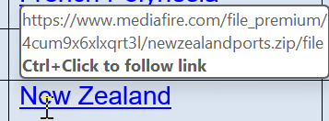
The downloaded file will be compressed in the .zip format. 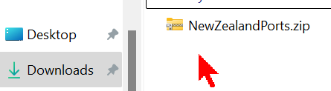
Uncompress (Extract) to a location of your choice and there will be a folder such as this: 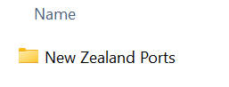
Open the folder to show two more folders: 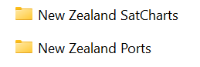
Open the New Zealand Ports folder to show the gpx file: 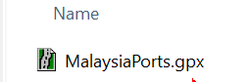
This file contains the list of ports to be imported to the Route and Mark Manager in OpenCPN.
Open the New Zealand SatCharts folder to show the collection of mbtiles charts: 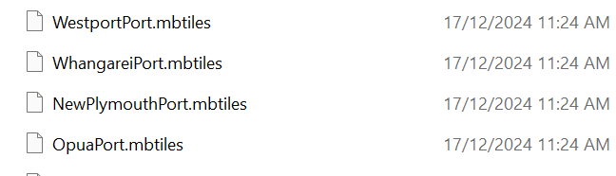
This folder contains the charts to be added to the OpenCPN program.

Display in the OpenCPN program
Launch OpenCPN, go to Options/Charts and select Add Directory. Navigate to where the downloaded files were saved, select the
New Zealand SatCharts folder and press Select Folder.
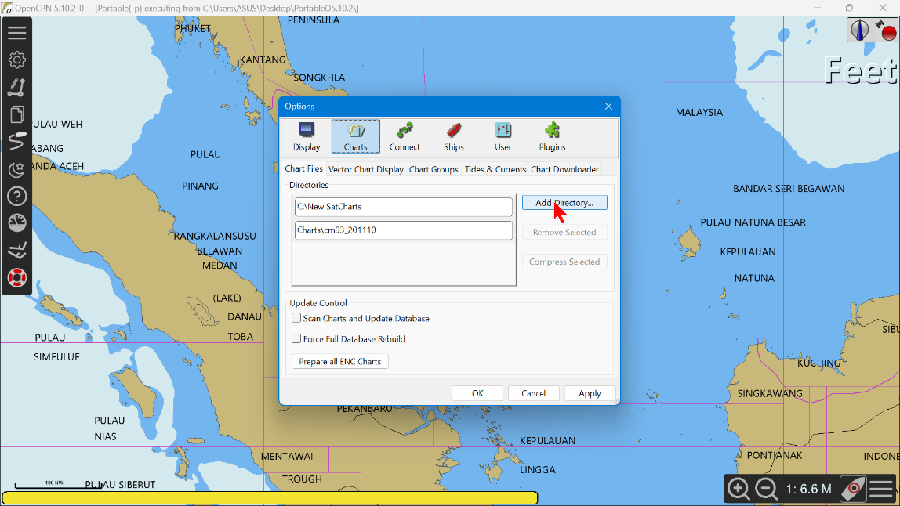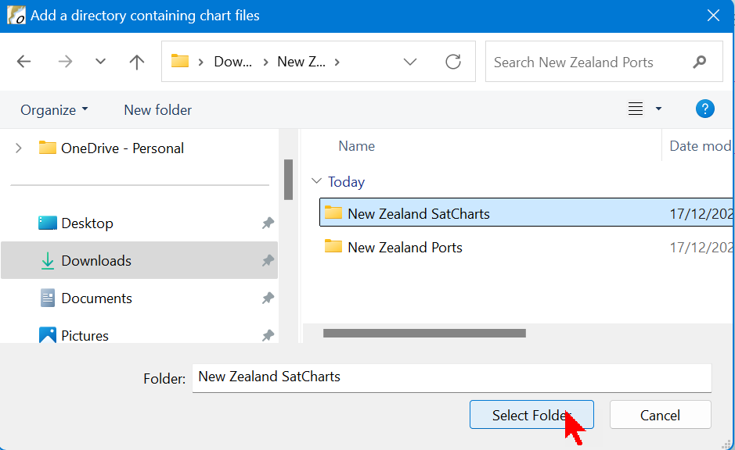
Update the database. Use the Route and Mark Manager to import the NewZealandPorts.gpx file.
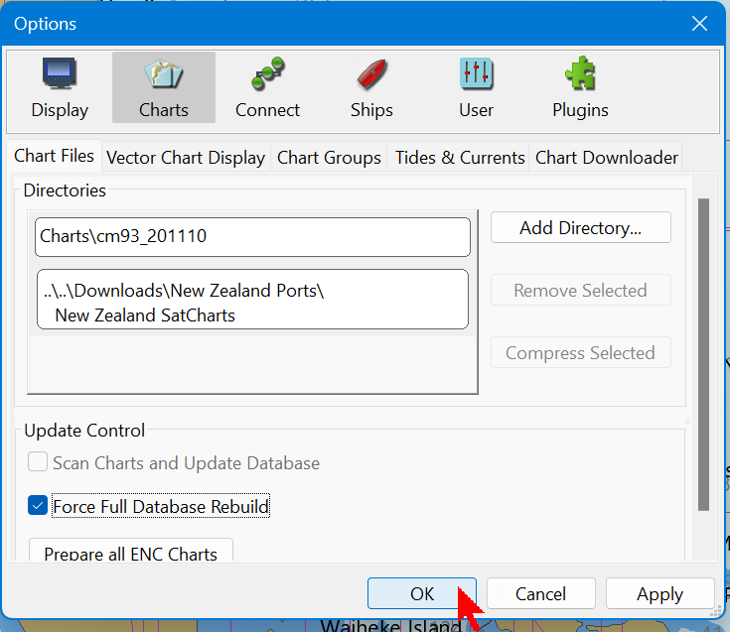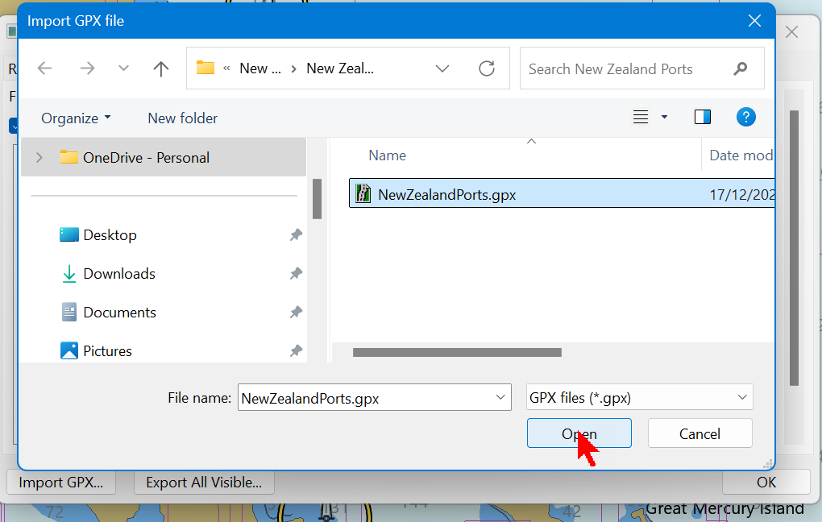
The Marks tab shows the port locations. As an example, select the Auckland Port and Properties.
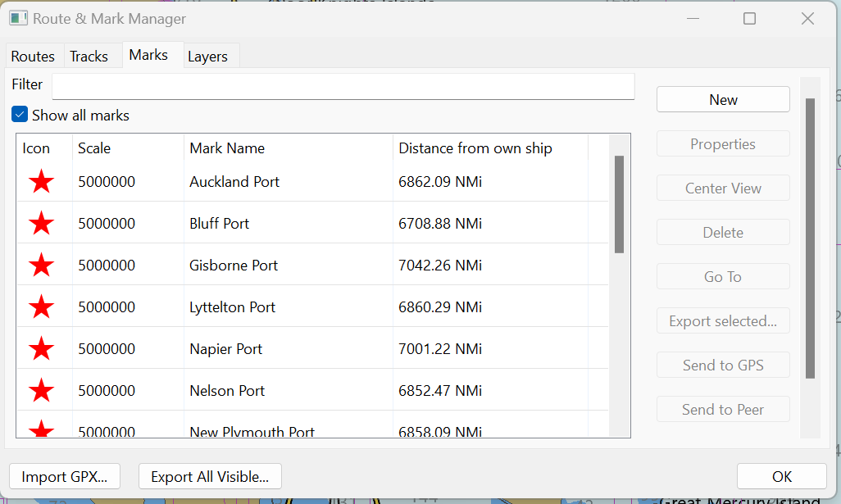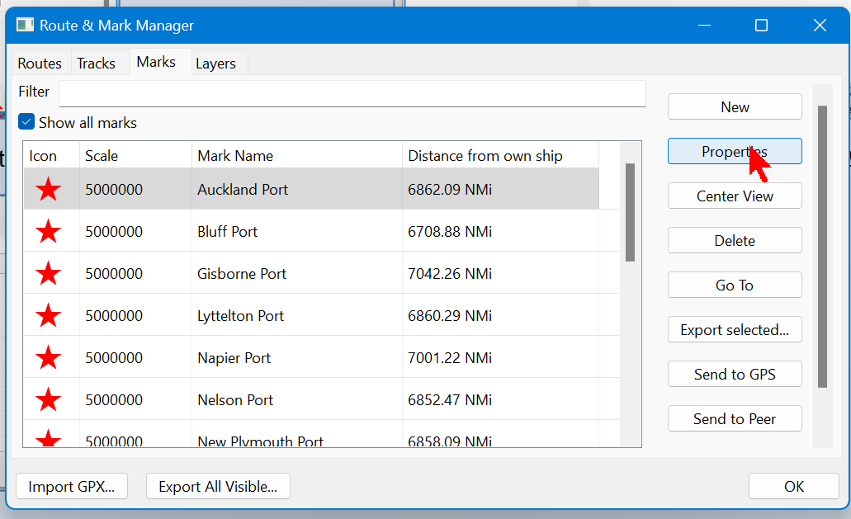
The Description tab has contact information. If you are online the Online link takes you to one of the sources for this information.
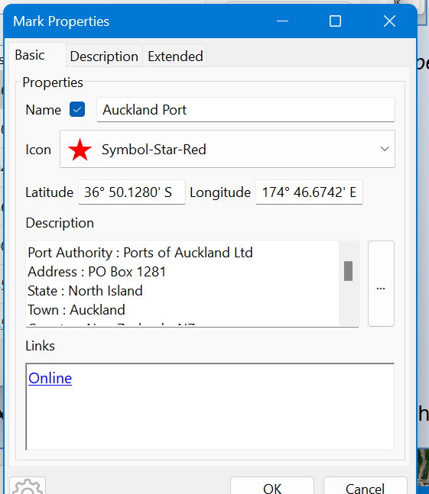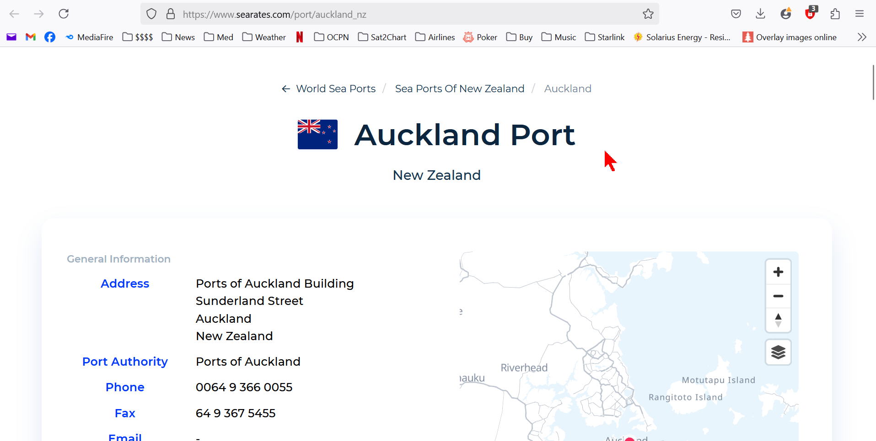
Open the Extended tab and click on the Tides icon to display the tides at this location at the current time.
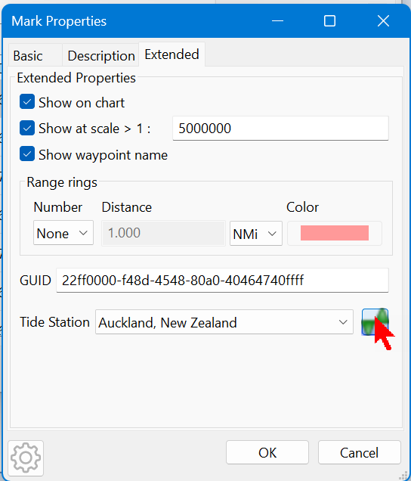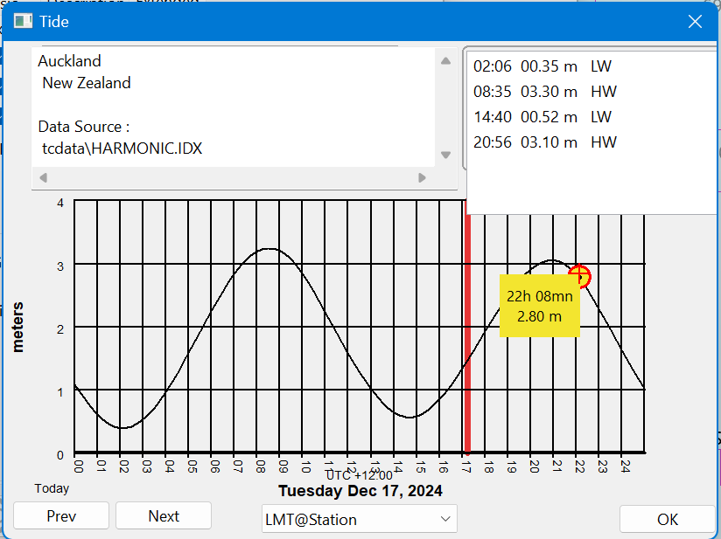

Zoom in on OpenCPN to show the satellite imagery chart for Auckland Port.
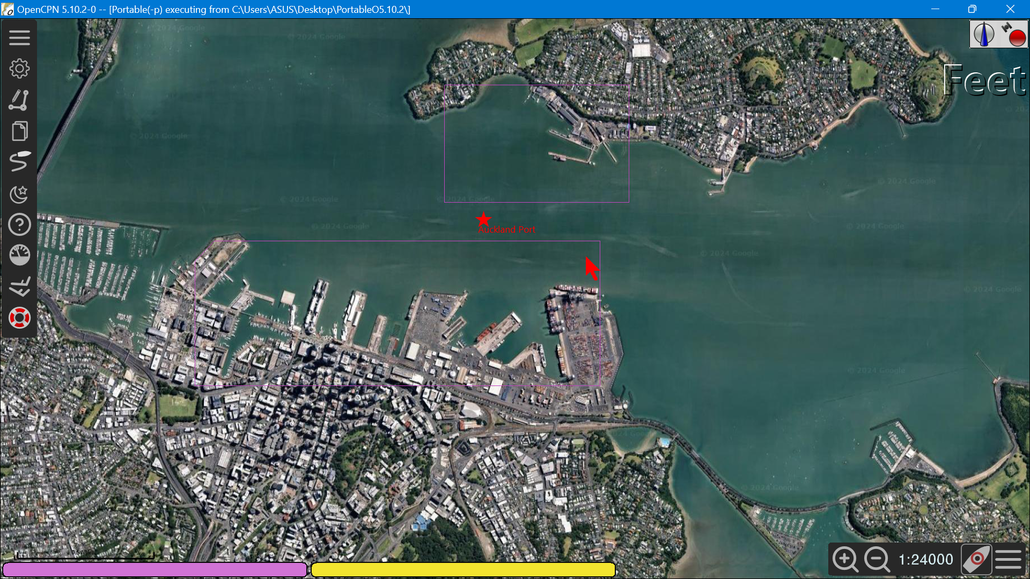
Terry Sargent yachties@yahoo.com.

