EXPLORE THE ‘PROPERTIES’ OF A WAYPOINT IN OpenCPN Terry Sargent, Yacht VALHALLA
Display the Route and Mark Manager. Select a waypoint and click on ‘Properties’. (Or double-click on the waypoint)
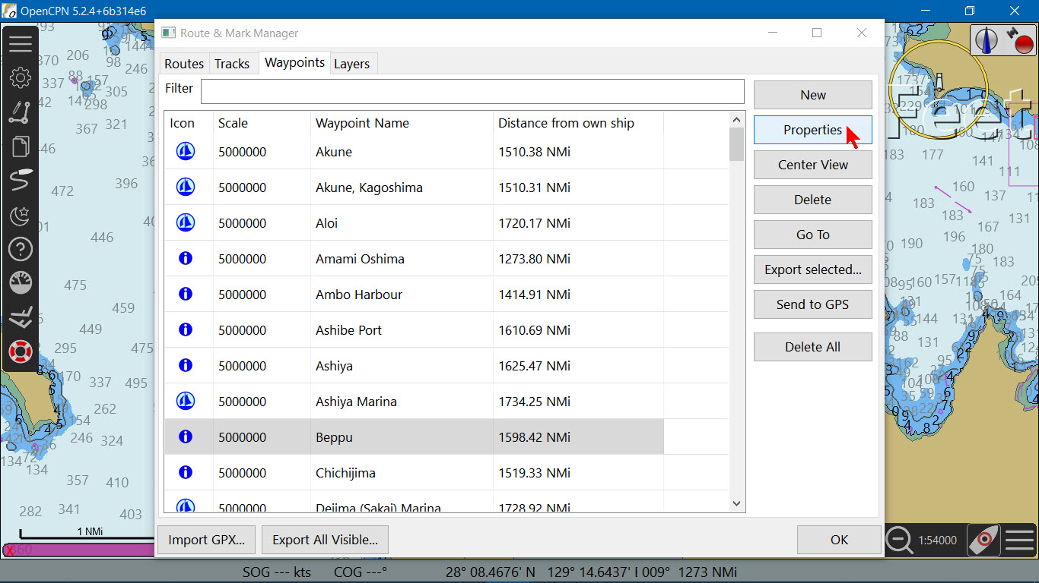
The waypoint properties window appears. The ‘Description’ window gives information about this waypoint.
NOTE: If you are online you can click on a link when it is displayed. This brings up the online source of information for this waypoint.
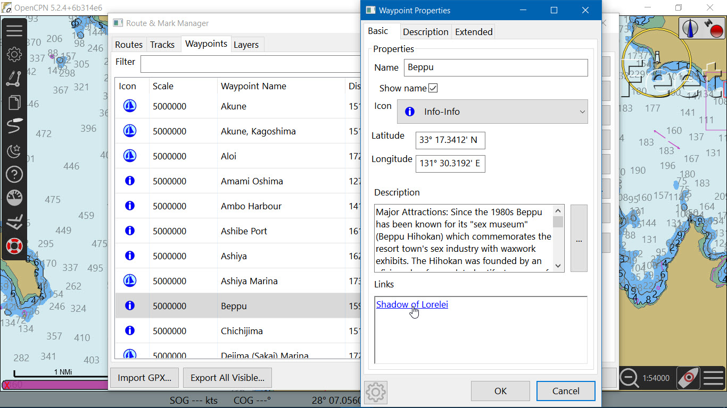
In this case the blog from SV Shadow of Lorelei is displayed in your browser.
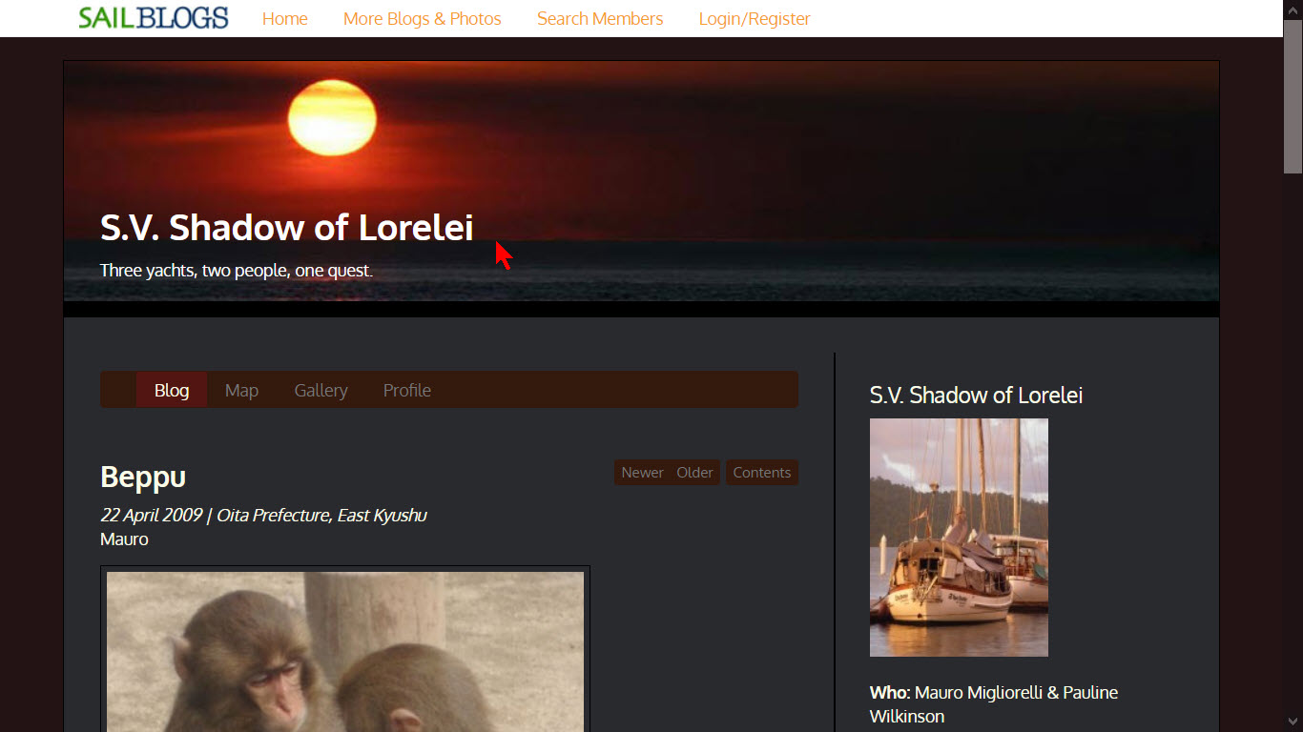
Click on the ‘Extended’ page under the Waypoint Properties.
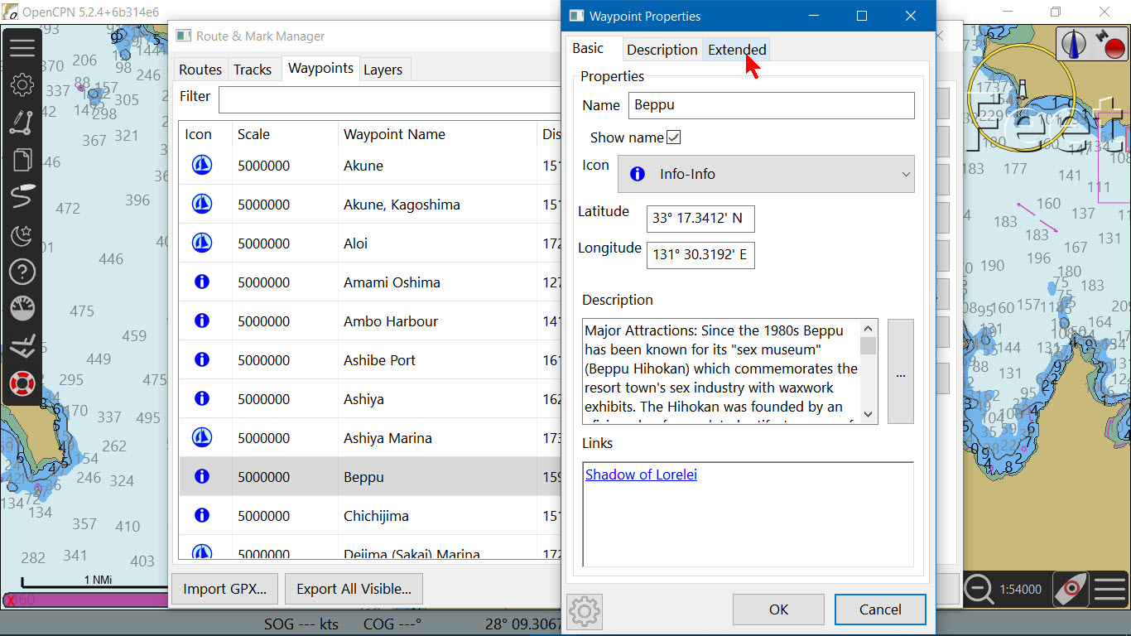
The nearest tide station to the waypoint is shown in the window.
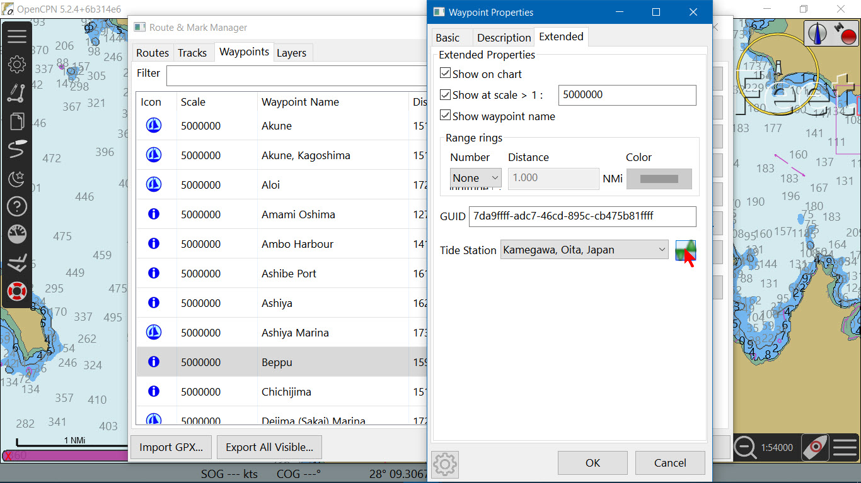
Click on the icon to display the tide station information.
